Abstract

1. I.Sicily  
An EpiDoc corpus for ancient Sicily

Jonathan Prag1, James Chartrand2, James Cummings1

University of Oxford1, OpenSky Solutions2

Email: jonathan.prag@merton.ox.ac.uk

This paper introduces the EpiDoc corpus of inscriptions on stone for ancient Sicily, *I.Sicily*. The project is one of the first attempts to generate a substantial regional corpus in EpiDoc. The project is confronting a number of challenges that may be of wider interest to the digital epigraphy community, including those of unique identifiers, linked data, museum collections, mapping, and data conversion and integration, and these are briefly outlined in the paper.

Keywords

Sicily, Epigraphy, Epidoc, Greek, Latin, Pleiades, multilingualism

1.Introduction: What is *I.Sicily*

*I.Sicily* is an online, open access, digital corpus of the inscriptions on stone from ancient Sicily.[1] The corpus aims to include all texts inscribed on stone, in any language, between approximately the seventh century BC and the seventh century AD. The corpus currently contains records for over 2,500 texts, and when complete is likely to contain c.4,000. The corpus is built upon a conversion from a legacy dataset of metadata in MS Access to EpiDoc TEI XML.[2] The XML records are held in an eXist database for xQuery access, and additionally indexed for full-text search using SOLR/Lucene. The corpus and related information (museum list, bibliography) are published as Linked Data, and are manipulated through a RESTful API. The records are queried and viewed through a web interface built with AngularJS and jQuery javascript components. Mapping is provided in the browser by the Google Maps API, and ZPR (Zoom, Pan, Rotate) image-viewing is provided by the IIIP image server and the OpenSeadragon javascript library.

At the time of writing (September 2015), the main conversion routine is being refined and the epigraphic texts are being collated for incorporation into the records. An ancillary database of museum collections in Sicily has been constructed and bibliography is held in a Zotero library. Extensive search facilities will be provided, including map-based and bibliographic searching. Individual inscriptions and individual museums will both be provided with URIs, as will personal names and individuals; places will be referenced using *Pleiades*; epigraphic types, materials, and supports using the EAGLE vocabularies.

2. The motivations for and origins of *I.Sicily*

The existing epigraphic landscape in Sicily is extremely diverse in two primary regards: on the one hand, the island has a very mixed cultural and linguistic make-up, meaning that the epigraphic material is itself extremely varied, with extensive use throughout antiquity of both Greek and Latin, as well as Oscan, Punic, Sikel, and Hebrew;[3] on the other hand, the publication of this material has a very uneven record and despite an excellent pre-twentieth century tradition, the existing *copora* are far from complete and the ability of key journals such as *SEG* or *AE* to keep pace with local publication has been limited.[4] A limited number of museum-based *corpora* have been published in recent decades (for Catania, Palermo, Messina, and Termini Imerese, as well as the material from Lipari), but this has not greatly improved the overall situation.

The combination of these two factors already means that locating, identifying, or working with a Sicilian inscription, or its publication record, is extremely challenging for anyone without extensive experience of the material. The situation is compounded by the universal and familiar challenges of the recording and accessibility of archaeological collections, whether held in museums, in archaeological stores, or elsewhere, and the lack of consistency in the publication of new material.

As noted in the introduction, some of the impetus for *I.Sicily* comes from a desire to exploit a substantial legacy dataset in MS Access. This consists of a single table originally constructed in MS Access 2000, and maintained erratically from the year 2000 onwards. The original purpose of this table was to gather data to assess the ‘epigraphic habit’ of ancient Sicily, and consequently the texts themselves were not the primary focus. However, the extent to which the dataset facilitated further study made increasingly clear its potential value for the study of Sicilian epigraphy.[5]

In its final form the table holds data across 39 different fields, for 2575 records. 17 of these fields detail publication history (*corpora* references and other bibliography); the other fields record information on the language, date, provenance, current location, epigraphic type, form and material of the inscriptions, together with a free-text field recording further information about the inscription and fields to record any autopsy undertaken. Almost all of this data is derived from existing publications.

The conversion from the original MS Access dataset was developed through a pipeline of known conversions going from MS Access to CSV to TEI P5 XML. The XSLT transformation of the table of data from TEI P5 XML to EpiDoc XML is the point in the process where further up-conversions of the data were made. These include the creation of the hierarchical EpiDoc XML as well as normalisation of dating and bibliographic records. This conversion is not meant to be repeated as the dataset, once converted to EpiDoc XML, will be edited in the *I.Sicily* website. While the conversion preserves the data from the MS Access dataset, it restructures and where possible improves or normalises it.

By virtue of the fact that *I.Sicily* begins from such rich metadata, to which texts, images, and further data will be added over time, and because this is in turn being supplemented by an on-going programme of autopsy, the form and content of *I.Sicily* is intended to be more akin to that of a true corpus than simply a text-database, seeking to combine a full record of past publication and study with a fully revised edition, and potential for multiple individuals to contribute to a process of on-going revision (see Fig. 1 for a draft edition of one inscription (*AE* 1962.314 = *I.Sicily* 820)).

3. The aims of *I.Sicily*

We outline briefly five areas in which *I.Sicily* aims to develop, facilitate and improve the study of epigraphic material from ancient Sicily.

3.1. Multilingualism

Sicily is traditionally described as a ‘melting pot’, the ‘crossroads of the Mediterranean’. The negative consequences of the separation of epigraphic material according to linguistic traditions have recently been highlighted and directly confronted by the *Corpus Inscriptionum Iudaeae/Palaestinae* (*CIIP*), edited by H. Cotton *et al.*[6] *I.Sicily* sets out to follow in that mould, since the different linguistic traditions of Sicily not only exist side-by-side but interact constantly throughout the island’s history, and no study of the epigraphic material can afford to ignore contemporary and parallel material in the other languages.[7] The situation created by basic technologies such as Unicode and EpiDoc XML mean that there is now no reason not to be language agnostic in the inclusion of material (the point may be obvious, but the tendency towards language-specific *corpora* is still marked). The opportunities and possibilities offered by these technologies are considerable, even at the most basic level, since, for example, searching can be made language specific or language neutral. One obvious area where Sicilian studies are currently hampered by this partitioning is in the study of onomastics. The *Lexicon of Greek Personal Names* records most instances of Greek names for the island, but Sicily is no less rich in non-Greek names (Latin and others), and at present there is no *onomasticon* for the island.[8] Simply by the marking-up and indexing of all names in the island’s inscriptions, *I.Sicily* will generate a powerful tool for future study. Although *I.Sicily* in its first phase is not undertaking morphological or syntactical mark-up, the encoding of all these text in XML constitutes the necessary first stage in such a development, and we see this as a highly desirable future project, and the possibilities for the field of historical linguistics are considerable. The incorporation of a full range of metadata on the epigraphic support, geographical location, chronology, etc. will likewise allow detailed analysis of cultural patterns and their relationship to language-use over time.[9]

3.2. Identification and Bibliography

Sicily presents a particularly extreme version of the common problem of identifying a text and its publication record. No existing *corpus* in either Greek or Latin comes close to full coverage (*CIL* X and *IG* XIV are the largest individual traditional corpora for the region, but both are over 125 years old and cover less than 30% of the material now known).[10] Existing online databases improve on this situation, but the results obtainable are of very varied value. The most comprehensive, in terms of the range of data recorded, is *EDR* (with which *I.Sicily* is collaborating), which currently reports 1,906 records for ‘Sicilia’; but this reduces to 833 when limited to texts on stone (‘lapis’ or ‘marmor’); contrast *I.Sicily*, with 2,563 records at the time of writing.[11] *Clauss Slaby* reports 4,374 records for ‘Sicilia’ (including Christian inscriptions, excluding ‘sigilla impressa’), but the return is inclusive of all kinds of epigraphic material, without indication or discrimination, contains some duplication, is much harder to reconcile to existing records, and records only text.[12] The *PHI* database of Greek inscriptions has a rich record of published Greek texts, but is text only and limited in outputs.[13] *SEG* references are available for 733 inscriptions on stone and *AE* references for 328 (data taken from the *I.Sicily* database and based upon comprehensive manual trawls of *SEG* and *AE*).

One major aim of *I.Sicily*, therefore, is to generate unique identifiers for each inscription - the *I.Sicily* number, in the form *ISic* 1234. These will be maintained as URIs, of the form:

http://csad.ox.ac.uk/sicily/inscription/ISic1234

*I.Sicily* is well placed to do this since its initial dataset is primarily a bibliographic concordance of the lapidary inscriptions of Sicily. One of the associated outputs of the project will therefore be an online bibliography for Sicilian epigraphy, and an online Zotero library has already been created with over 700 records which are referenced in the EpiDoc files.[14] A locally cached version of the bibliography will be presented at the *I.Sicily* site to facilitate detailed bibliographic searching (including the identification of inscriptions by publication) and to allow the generation of customised concordances.

A further element of bibliographic information which *I.Sicily* will include is the cross-referencing and linking to online editions of major antiquarian *corpora* of Sicilian inscriptions. A growing number of these are already available in digital format and several are already mounted in the Arachne archive, making direct page-citation possible.[15]

The richness of *I.Sicily’*s records in this area mean that *I.Sicily* is currently collaborating with both *Trismegistos* and *IDES* (‘Integrating Digital Epigraphies’).[16] The former aims to generate *TM* numbers for all the Sicilian material (which *I.Sicily* will include); the latter is to assist *IDES* in the refining of links between, e.g., *PHI* and *SEG* records, and to improve *I.Sicily*’s own recording of *PHI* numbers.

3.3. Identification and Collections

The traditional focus of epigraphic study upon the text, rather than the epigraphic support, means that epigraphic publication in the past has frequently been relatively limited in the information which it has recorded about the object on which the inscription is inscribed. This is a familiar complaint, and one which *I.Sicily* will address wherever possible through full object description and a rich photographic record. However, a corollary of this general problem is a very low level of information regarding current location and in particular the infrequent recording of museum inventory numbers or similar information. This situation is inevitably exacerbated by the substantial (and very positive) reorganisation and redevelopment of museum collections in Sicily recent decades – including a significant increase in the number of museums and public collections.

*I.Sicily* is making use of the TEI <msIdentifer> element, with its associated sub-elements in order to record details of institutional collections and inventory numbers wherever possible.[17] In order to maximise the value of this, we have adopted two further courses of action. In the first place, as part of the larger ambition of undertaking autopsy of every stone contained within the corpus, we are working in close collaboration with museums on the island to improve our records of individual museum holdings. Where possible we aim to include associated archival information, such as copies of inventory records. This work currently includes a major sub-project to catalogue the epigraphic collection of the Museo Archeologico Regionale Paolo Orsi at Siracusa, and we are also currently working with collections at Adrano, Halaesa (Tusa, ME), and Catania.[18] It is hoped that this work will be of considerable value to the museums themselves, since access to the *I.Sicily* records should facilitate the curation, display and accessibility of the inscriptions (see below also on translations), and we welcome future collaboration with other museums on the island.

Secondly, in collaboration with Dr Michael Metcalfe, *I.Sicily* has developed a database of Sicilian archaeological collections (130 at the time of writing). This database is mounted online alongside the epigraphic corpus, in a searchable format, including map-based searching. In order to facilitate the generation of linked data, the individual museum records will be maintained with URIs, of the form:

http://csad.ox.ac.uk/sicily/museum/SicMus123

The linking of the epigraphic and museum databases will enable the searching and reporting of inscriptions by museum collection as well as the easy locating of the appropriate collection.

3.4. Location, location, location

*I.Sicily* is actively generating rich geo-data for the individual inscriptions, both for the original findspot/provenance and the current location (whether museum-based, on-site, or elsewhere), and we aim to provide map-based searching for inscriptions, as well as text-based searching by ancient and modern place-names. In addition to full listing wherever possible of both ancient and modern place names for epigraphic provenance, we are working to provide detailed location information for each find-spot and the inscription’s current location, through a combination of library and map-based research and the use of autopsy and *GIS* recording. At present geo-data is being recorded in two forms, both through the use of explicit geographical locations in the form of longitude and latitude records in decimal degree form (using <geo> elements), and through the use of Pleiades URI references wherever possible.[19] We are committed to the long-term use of Pleiades as our primary reference for ancient places, and to that end we aim to update and improve the Pleiades data for Sicilian locations, in particular name data and sub-locations, in conjunction with the editing of the *I.Sicily* records.[20]

3.5 Searching

In order to support the aims outlined above, *I.Sicily* has taken a different approach to search and browse. Although standard form-based search with paged results, like that of Google, makes sense for very large result sets, the comparatively small number of records in *I.Sicily* (thousands versus the estimated 30 trillion web pages indexed in Google) lends itself to a more direct and interactive approach - a spreadsheet/grid model (similar to Microsoft Excel) that runs directly in the browser. Although it is tempting to repeat the standard web-form model, following the argument that that’s what users expect, the spreadsheet approach will be much easier to use, narrowing quickly and accurately to more easily interpreted results. Further, any subset of the spreadsheet, generated from interactive filtering, can, with a single button push, be exported to CSV (comma separated values) for use outside I*.Sicily*. The spreadsheet interacts particularly well with maps: all findspots or museums in a filtered subset of the grid can be simultaneously shown on the map (see Fig. 2). The spreadsheet model also provides a very quick and intuitive (since so many people are familiar with spreadsheets) means for editing records (in this case, inscriptions and museums) online. This web-based spreadsheet model has only recently become feasible for the web, as web browsers have added more functionality and new javascript libraries have been developed.

3.6. Translations

As was extensively discussed at the first EAGLE conference (Paris 2014), the creation and availability of translations is a major goal of the EAGLE project and its collaborators, and *I.Sicily* is no less committed to that ambition.[21] Translations are rarely available for any of the published Sicilian inscriptions.[22] It is obvious that the inclusion of translations will make the material much more accessible to a wider audience both of students and the general public. Equally, provision of translations will add to the value of the database as a resource for museums and others curating the inscriptions recorded in the database. To that end, a long-term ambition of *I.Sicily* is to include translations wherever possible in both English and Italian. We see this as one obvious area where public contribution (‘crowd-sourcing’) will be invaluable (see below).

4. Limitations and future ambitions

The scale of the enterprise, and the available resources, mean that in its current form the project has limited itself to inscriptions engraved on stone (the coverage of rupestral inscriptions/graffiti and of inscriptions painted on stone/plaster is regrettably uneven). However, there is no reason in principle not to extend coverage in future to include inscriptions on other materials. Similarly, although as noted above the current project does not include a programme to mark up linguistic features of the texts, the commitment to the long-term maintenance of the corpus and the open availability of the underlying XML records means that such a project would be entirely possible in the future.

A core principal of the project is that wherever possible an inscription record should be supported by recent autopsy and not simply derived from the existing literature. Necessarily, this process is a slow one, and the majority of records at this stage consist of information derived from secondary sources (earlier editions and other publications). Individual inscription records will contain a clear indication of the editorial state of the record (from unchecked through to fully edited) and additionally whether the record is underpinned by autopsy. In both cases, clear records will be kept of editorial responsibility, autopsy and authorship as appropriate. In order to speed up the development of the corpus, and to encourage those working on the material to take ownership of it for themselves, we aim to enable individuals to submit new records and emendations or additions to existing records (such as translations, images, location information), both in the Epigraphic database and the Museums database. To this end, we welcome collaboration with those undertaking epigraphic projects in Sicily, and aim to offer the ability for other projects to publish their editions through *I.Sicily*.[23] We are also exploring the potential of the *corpus* as a teaching resource both for epigraphy in general and for the teaching of EpiDoc. This latter aspect has already been initiated through a Teaching Project Award (2014-2015) from the Humanities Division of the University of Oxford, and we aim to develop this further in the coming year, as part of the work of incorporation and conversion of texts into the existing dataset.

It is our long-term ambition that *I.Sicily* might become the default location for the publication and dissemination of Sicilian inscriptions; in the shorter term, we hope that it will serve as valuable portal in the world of Sicilian epigraphy and of ancient world open linked data, greatly improving the accessibility of Sicilian epigraphy and so enriching the study of the ‘crossroads of the Mediterranean’.

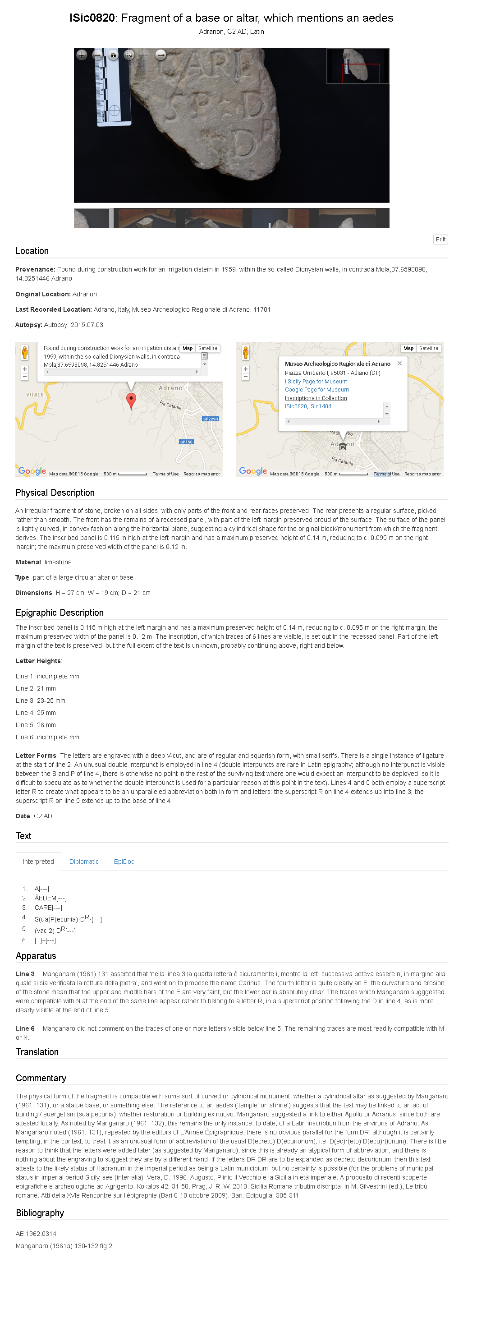Fig. 1: sample edition.

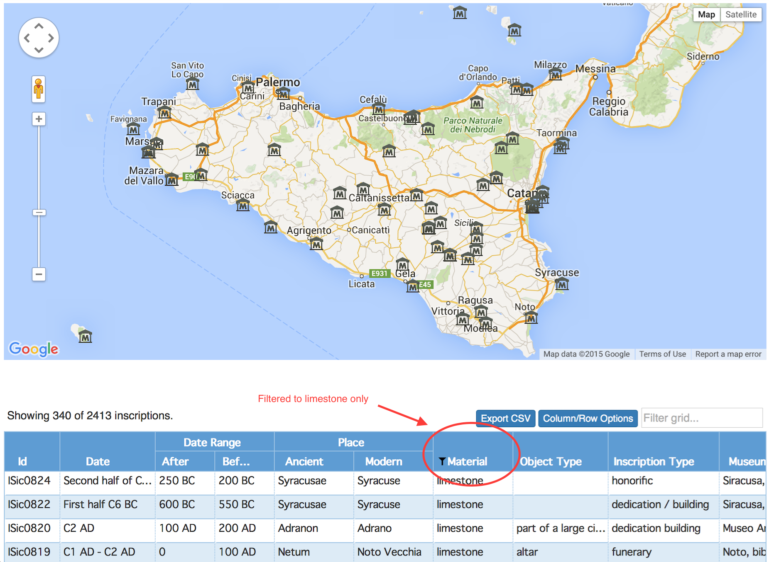

**Fig. 2**. Screenshot of map-based searching (museum locations) and of part of the spreadsheet/grid search interface employed in *I.Sicily*.

**Bibliography**

Castelli, G. L., Principe di Torremuzza, *Siciliae et objacentium insularum veterum inscriptionum nova collectio prolegomenis et notis illustrata, et iterum cum emendationibus, & auctariis evulgata*, Palermo 1784.

Cotton, H. M. and Price, J., *Corpus inscriptionum Iudaeae / Palestinae*: *a multilingual corpus of inscriptions*, in M. Mayer i Olivé, G. Baratta, A. Guzmán Almagro (eds.), *XII Congressus Internationalis Epigraphiae Graecae et Latinae, Acta*, Barcelona 2007, 327-332.

Cotton, H. M., Di Segni, L., Eck, W., Isaac, B., *Corpus Inscriptionum Judaeae/Palaestinae*, *ZPE,* 127 (1999), 307–308.

De Vido, S., *Corpora epigrafici siciliani da Gualtherus a Kaibel*, in M. I. Gulletta (ed.), *Sicilia Epigraphica. Atti del convegno internazionale, Erice, 15-18 ottobre 1998*, Pisa 1999, I, 221-250.

Dubois, L., *Inscriptions grecques dialectales de Sicile : contribution à l'étude du vocabulaire grec colonial*, Rome 1989.

Dubois, L., *Inscriptions grecques dialectales de Sicile. Tome II,* Geneva 2008.

Gulletta, M. I. (ed.), *Sicilia Epigraphica. Atti del convegno internazionale, Erice, 15-18 ottobre 1998*, 2 vols., Pisa 1999.

Kaibel, G., *Inscriptiones Italiae et Siciliae* (= *IG* XIV), Berlin 1890.

Korhonen, K., *Language and Identity in the Roman Colonies of Sicily*, in R. J. Sweetman (ed.), *Roman Colonies in the First Century of their Foundation,* Oxford 2011, 7-31.

Manganaro, G., *Greco nei pagi e latino nelle città della Sicilia romana tra I e VI sec. d.C*., in A. Calbi, A. Donati and G. Poma (eds), *L'epigrafia del villaggio*, Faenza 1993, 543-594.

Mommsen, T., *Inscriptiones Bruttiorum Lucaniae Campaniae Siciliae Sardiniae Latinae. Pars posterior. Inscriptiones Siciliae et Sardiniae* (= *CIL* X.2), Berlin 1883.

Orlandi, S., Santucci, R., Casarosa, V. and Liuzzo, P. M. (eds.), *Information Technologies for Epigraphy and Cultural Heritage, Proceedings of the First EAGLE International Conference*, Rome 2014, online at: Sapienza Università Editrice. Published online at: http://www.eagle-network.eu/wp-content/uploads/2015/01/Paris-Conference-Proceedings.pdf [Accessed 26.09.2015].

Prag, J. R. W., *Epigraphy by numbers: Latin and the epigraphic culture in Sicily*, in A. E. Cooley (ed.), *Becoming Roman, Writing Latin?*, Portsmouth RI 2002, 15-31.

Prag, J. R. W., *Nouveaux regards sur les élites locales de la Sicile républicaine*, in *Histoires et sociétés rurales*, 19 (2003), 121‑132.

Prag, J. R. W., *Sicily and the Roman Republic 241-44 BC: provincialization and provincial identities*, PhD thesis, Department of History, University College London, 2004.

Prag, J. R. W., *Ciceronian Sicily: the epigraphic dimension*, in J. Dubouloz, S. Pittia (eds), *La Sicile de Cicéron, Lectures des Verrines*, Besançon, 2007, 245‑271.

Prag, J. R. W., *Sicilia and Britiannia: Epigraphic Evidence for Civic Administration*, in C. Berrendonner, M. Cébeillac Gervasoni and L. Lamoine (eds), *Le Quotidien municipal dans l’Occident romain*, Clermont-Ferrand, 2008, 67‑81.

Prag, J. R. W., *Sicilia Romana tributim discripta*, in M. Silvestrini (ed.), *Le tribù romane. Atti della XVIe Rencontre sur l’épigraphie (Bari 8-10 ottobre 2009)*, Bari, 2010, 305‑311.

Salmeri, G., *I caratteri della grecità di Sicilia e la colonizzazione romana*, in G. Salmeri, A. Raggi and A. Baroni (eds), *Colonie romane nel mondo greco*, Rome 2004, 255-308.

Tribulato, O. (ed.), *Language and linguistic contact in ancient Sicily*, Cambridge 2012.

Wilson, R., R. Talbert, S. Gillies, J. Åhlfeldt, J. Prag, J. Becker, T. Elliott, *Places: 462097 (Apollonia),* in *Pleiades* <http://pleiades.stoa.org/places/462097> [accessed 26.09.2015].

*I.Sicily* gratefully acknowledges the financial support of the John Fell Fund of the University of Oxford, and of the Warden and Scholars of the House or College of Scholars of Merton in the University of Oxford.

Acknowledgements

1. The corpus will be mounted at www.csad.ox.ac.uk/sicily/isicily, but is presently on a development server. A public face is currently maintained via a blog at http://isicily.wordpress.com/, as well as on Facebook at www.facebook.com/ISicily and on Twitter via I.Sicily@Sicilyepigraphy.
2. http://sourceforge.net/p/epidoc/wiki/Home/ [accessed 26.09.2015].
3. Recent overview of much of the linguistic tradition in Tribulato 2012; and of the epigraphic material in Gulletta 1999.
4. For an overview of the *corpora* tradition up to the twentieth century, see De Vido 1999.
5. The principal results were published in Prag 2002, revised in Prag 2004: 159-188; cf. Prag 2003, 2007, 2008, 2010.
6. Original notice in Cotton *et al.* 1999; presentation in Cotton and Price 2007.
7. See e.g. Manganaro 1993, Prag 2002, Salmeri 2004, Korhonen 2011, Tribulato 2012.
8. www.lgpn.ox.ac.uk/ [accessed 26.09.2015].
9. See Prag 2002 for a first effort in this direction.
10. Mommsen 1883; Kaibel 1890.
11. www.edr-edr.it/ [accessed 26.09.2015]
12. www.manfredclauss.de/ [accessed 26.09.2015].
13. http://noapplet.epigraphy.packhum.org/regions/1156 [accessed 26.09.2015].
14. www.zotero.org/isicily (private at the time of writing, but to be made public when the main site is launched) [accessed 26.09.2015].
15. E.g. Castelli 1784, at http://arachne.uni-koeln.de/books/Castelli1784 [accessed 26.09.2015].
16. www.trismegistos.org/ [accessed 26.09.2015] and http://ides.io/ [accessed 26.09.2105].
17. www.tei-c.org/release/doc/tei-p5-doc/en/html/ref-msIdentifier.html [accessed 26.09.2015].
18. We gratefully acknowledge the ongoing support of dott.ssa G. Lamagna and dott.ssa A.M. Manenti at Siracusa, as well as previous directors of the Museo Archeologico at Siracusa, dott.ssa C. Ciurcina and dott.ssa B. Basile; of dott.ssa A. Merendino at Adrano; of dott.ssa G. Tigano and dott. R. Burgio at Messina; and of dott.ssa M.G. Branciforte at Catania.
19. http://pleiades.stoa.org/ [accessed 26.09.2015].
20. See e.g. Wilson *et al.*  2015. Valeria Vitale (KCL) is currently undertaking a significant programme of data improvement in Pleiades on behalf of *I.Sicily*; we are grateful to Tom Elliott and Jeffrey Becker for their support.
21. See Orlandi *et al.* 2014: Part II.
22. French translations appear in Dubois 1989 and Dubois 2008.
23. We are currently establishing just such a collaboration with Prof.ssa M. Sgarlata and Drs Lo Faro and Gradante, in support of their project to produce the volume of *Inscriptiones Christianae Italiae* for the San Giovanni Catacombs in Siracusa.